

OpenL Tablets WebStudio User's Guide

^{OpenL Tablets 5.11.05.10.1}
OpenL Tablets BRMS

Document number: TP_EPB_7.1.0_OpenLWSt_User_3.0_SN
Revised: 06-06-2013

OpenL Tablets Documentation is licensed under a Creative Commons Attribution 3.0 United States License.
Table of Contents
Preface 5
Audience 5
Related Information 5
Typographic Conventions 5
Chapter 1: Introducing OpenL Tablets WebStudio 7
What Is OpenL Tablets WebStudio? 7
Working with Projects in OpenL Tablets WebStudio 7
OpenL Tablets WebStudio Components 8
Security Overview 9
Chapter 2: Getting Started 10
Signing In to OpenL Tablets WebStudio 10
Understanding the User Interface 10
Rules Editor 10
Repository Editor 16
Chapter 3: Using Rules Editor 18
Filtering Projects 18
Opening a Module 19
Managing Projects 19
Editing and Saving a Project 19
Reverting Project Changes 19
Viewing Tables 22
Modifying Tables 23
Editing Range Data Types 24
Copying Tables 28
Performing a Search 29
Simple Search 29
Advanced Search 30
Creating New Table 32
Datatype Table Wizard 32
Data Table Wizard 34
Simple Rules Wizard 36
Chapter 4: Editing and Testing Functionality 39
Editing Tables 39
Editing Table Properties 39
Unit Tests 46
Navigation 46
Run Tests 46
Creating New Test 50
Tracing 50
Benchmarking 54
Chapter 5: Using Repository Editor 56
Browsing Design Repository 56
Filtering the Project Tree 57
Creating Projects in Design Repository 57
Create a Project from Template 58
Create a Project from Excel File(s) 59
Create a Project from ZIP Archive 61
Import a Project from Workspace 62
Opening a Project 63
Closing a Project 64
Editing a Project 64
Saving a Project 64
Defining Project Dependencies 65
Modifying a Project 66
Modifying Project Properties 66
Modifying Project Contents 69
Copying a Project 71
Removing a Project 72
Deleting a Project 72
Erasing a Project 72
Deploying Projects 73
Creating a Deploy Configuration 73
Defining Projects to Deploy 73
Deploying a Deploy Configuration 74
Opening Deployed Configurations 74
Redeploying Projects 75
Comparing Project Revisions 76
Using Administration Tools 77
Managing System Settings 77
Common Settings 78
Repository Settings 78
System Settings 79
User Management 79
Manage Groups 79
Manage Users 82
Index 85

Preface
This preface is an introduction to the OpenL Tablets WebStudio User's Guide.
The following topics are included in this preface:
- Audience
- Related Information
- Typographic Conventions

Audience
This guide is intended for the following users:
Audience
User type | Purpose | Required knowledge
Business users | View and modify company business rules stored in tables. | Knowledge of decision tables is required.
Developers | - Manage technical details of rule tables.  - Organize and deploy rule projects. | Knowledge of OpenL Tablets technology is required.

Related Information
OpenL Tablets WebStudio is a tool from OpenL Tablets product. For information on OpenL Tablets Rules, see OpenL Tablets Reference Guide.

Typographic Conventions
The following styles and conventions are used in this guide:
Typographic styles and conventions
Convention | Description
Bold | - Represents user interface items such as check boxes, command buttons, dialog boxes, drop-down list values, field names, menu commands, menus, option buttons, perspectives, tabs, tooltip labels, tree elements, views, and windows.  - Represents keys, such as F9 or CTRL+A.  - Represents a term the first time it is defined.
Courier | Represents file and directory names, code, system messages, and command-line commands.
Courier Bold | Represents emphasized text in code.
Select File > Save As | Represents a command to perform, such as opening the File menu and selecting Save As.
Italic | - Represents any information to be entered in a field.  - Represents documentation titles.
< > | Represents placeholder values to be substituted with user specific values.
Hyperlink | Represents a hyperlink. Clicking a hyperlink displays the information topic or external source.

Chapter 1: Introducing OpenL Tablets WebStudio
OpenL Tablets WebStudioThis section introduces the main OpenL Tablets WebStudio concepts.
The following topics are included in this section:
- What Is OpenL Tablets WebStudio?
- Working with Projects in OpenL Tablets WebStudio
- OpenL Tablets WebStudio Components
- Security Overview
- User Perspectives

What Is OpenL Tablets WebStudio?
OpenL Tablets WebStudioOpenL Tablets WebStudio (further also referred as WebStudio) is a web application employed by business users and developers to view, edit, and manage business rules and rule projects created using OpenL Tablets technology. For information on OpenL Tablets, see OpenL Tablets Reference Guide.
By using OpenL Tablets WebStudio, users can modify rules directly in a web browser without installing additional tools. OpenL Tablets WebStudio provides better functionality than the OpenL Tablets Eclipse feature in terms of browsing projects, modifying rules, viewing errors, and executing tests. However, for more advanced activities, such as compiling Java code, generating static wrappers, and running Ant scripts, users must use Eclipse.

Working with Projects in OpenL Tablets WebStudio
OpenL Tablets WebStudioOpenL Tablets WebStudio is intended for a multi-user environment. It provides a centralized storage of rule projects called rules repository. Rules repository is stored on the OpenL Tablets WebStudio server and can be accessed by all users. However, users cannot modify projects directly in rules repository. Instead, to make modifications to a project, users must execute the following procedure:
Procedure for modifying a project
Step | Action | Description
1 | Open a project for editing. | Opening a project for editing (the project gets the Editing status) creates its copy in user’s workspace, a specific location on the OpenL Tablets WebStudio server. Working copies of projects made editable by the particular user are stored there. Users can only access their personal workspaces.  A project in the Editing status is locked in rules repository to avoid loss of information. Other users cannot edit it until the project is saved. Other users can only open projects in the Editing status in read only mode.
2 | Modify a project. | Modifications to a project in the Editing status are performed on the working copy stored in user's workspace. Modifications are not immediately visible to other users.
3 | Save a project. | Saving a project copies the modified copy of the project from user's workspace to rules repository. A new revision of the project is created in rules repository. A project can be restored to any of its previous revisions.  From this point, changes are visible to other users and the project is available for editing.
In addition to opening projects for editing (the project obtains the Editing status) and their saving, users can also open (the project obtains the Opened status) and close them. An open project is copied from rules repository to user's workspace, but the user cannot modify its contents. If a user only wants to view contents of a project, opening the project is recommended instead of making it editable. A project in the Editing status is locked for editing by other users.
Closing a project deletes it from user's workspace without saving changes and does not affect the revision in rules repository. Closed projects can be browsed in repository editor but are not available in Rules Editor.

OpenL Tablets WebStudio Components
OpenL Tablets WebStudioOpenL Tablets WebStudio consists of the following main components:
OpenL Tablets WebStudio components
Component | Description
Rules Editor | Graphic user interface running in a web browser allowing users to browse rule modules, modify table data, and run tests.  Rules Editor is the default user interface displayed when user opens OpenL Tablets WebStudio.  Rules Editor does not display all rule module files but provides a logical view of rules stored in a module. This view is convenient for users who modify business rules.  Rules Editor displays only modules available in projects stored in user's workspace. To retrieve a project to user's workspace, the project must be opened or in the Editing status. For information on opening and editing projects, see Working with Projects in OpenL Tablets WebStudio.  For detailed information on using Rules Editor, see Chapter 3: Using Rules Editor.
Repository editor | Graphic user interface running in a web browser allowing users to browse and manage projects in rules repository.  Unlike Rules Editor, repository editor displays physical contents of rule projects.  Users can easily switch between Rules Editor and repository editor in user interface.  Repository editor provides the following main functions:  - uploading projects from the file system to rules repository  - editing, saving, opening, and closing projects  - modifying project structure and properties  - managing project revisions and dependencies  - copying and deleting projects in rules repository  - managing and tracing deploy configurations  For detailed information on using repository editor, see Chapter 5: Using Repository Editor.
Rules repository | Centralized storage of rule projects accessible by all OpenL Tablets WebStudio users. Projects uploaded to rules repository are visible to other users.  Rules repository creates a separate project revision each time a project is saved. You can open any project revision if required.
Deploy Configurations repository | Centralized storage of final rule projects delivered to the production environment where solution applications use them.  Projects can be deployed to deployments repository from rules repository using deploy configurations. A deploy configuration is a specific OpenL Tablets WebStudio project type. It stipulates which rule projects and project revisions must be deployed to production repository. Deploy configurations are saved and versioned so that developers can identify which specific rule project revisions are deployed.
User workspace | Project storage on the server containing projects edited by users. Each user has a personal workspace not accessible by others.

Security Overview
OpenL Tablets WebStudioOpenL Tablets WebStudio supports the following user modes:
- Single – In this mode only one user who is currently logged in on the computer can work in OpenL Tablets WebStudio. You will want to select this mode if you are going to install WebStudio on your local machine. All user projects are located in the root of the user-workspace directory. Single user mode is set by default and does not require additional settings. Moreover, the system works faster in this mode but neither user management nor access control is provided. In the other words, you don’t need to login/logout in the system.
- Multi - This mode enables multiple users to work in OpenL Tablets WebStudio and supports a security mechanism restricting access to certain product functions based on user access rights. Each OpenL Tablets WebStudio user is identified by a unique name. When a user opens OpenL Tablets WebStudio in the web browser, a login screen appears and the user name and password must be specified. Users can have varied levels of access in OpenL Tablets WebStudio. For example, system administrators usually have full access to all OpenL Tablets WebStudio functions, whereas some other users only have access rights to view or modify business rules. In this mode user’s projects are located in the user-workspace\<user name> folder.

Chapter 2: Getting Started
This section explains logging in to OpenL Tablets WebStudio and briefly introduces the user interface.
The following topics are included in this section:
- Signing In to OpenL Tablets WebStudio
- Understanding the User Interface

Signing In to OpenL Tablets WebStudio
OpenL Tablets WebStudioTo sign in to OpenL Tablets WebStudio, proceed as follows:
- In the web browser address bar, enter the OpenL Tablets WebStudio URL provided by the system administrator.
The OpenL Tablets WebStudio URL has the following pattern:
http://<server>:<port>/webstudio
In the Single mode (See Security Overview for details), by default the user is automatically logged in using the Windows account.
In the Multi-user mode the following form appears.
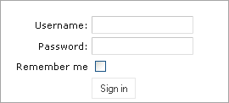
Figure 1: Sign in window
- If the Sign in window appears, enter your user name and password provided by the system administrator and click Sign in.

Understanding the User Interface
OpenL Tablets WebStudioThe OpenL Tablets WebStudio user interface consists of the following main parts:
- Rules Editor
- Repository Editor

Rules Editor
This section briefly introduces Rules Editor. For detailed information on tasks that can be performed in Rules Editor, see Chapter 3: Using Rules Editor.
The following topics are included in this section:
- Rules Editor Overview
- View Modes

Rules Editor Overview
Rules Editor provides controls for users to browse rule modules and modify table data. This is the default editor opened when a user logs in.
Rules Editor resembles the following:
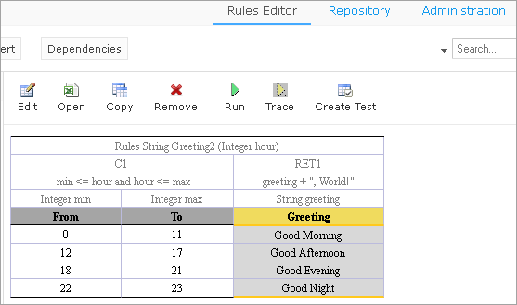
Figure 2: OpenL Tablets WebStudio Rules Editor
Rules Editor displays one module at a time. To switch between modules, the user must select a module in the Projects tree. One rule project can contain several modules.
The left pane displays the module tree providing a view of elements in the currently displayed rule module.
The middle pane displays contents of the table selected in the left pane and provides controls for modifying table data, running tests, and checking test results.
The right pane displays properties of the currently displayed table.
The upper part of the window contains toolbars with the following controls:
Rules Editor toolbar buttons
Button | Description
Switches to view with table headers and/or Excel formulas.
For information on view modes, see View Modes.
 | Opens a page for reverting module changes
Runs a simple search.
For information on performing searches, see Performing a Search.
 | Refreshes OpenL Tablets WebStudio with latest changes in Excel files.
 | Initiates the table creation wizard.
 | Displays recently visited tables instead of the module tree.
 | Returns to the module tree view.
 | Initiates a dialog for comparing Excel files.
 | Opens Dependency graph
Switches user interface to repository editor.
For general information on repository editor, see Repository Editor.
 | Opens OpenL Tablets WebStudio help.
 | Logs the user out of OpenL Tablets WebStudio.
Switches user interface to rules editor
For general information on rules editor, see Rules Editor
 | Switches user interface to the Administration mode

View Modes
OpenL Tablets WebStudio provides the following display modes for showing rule elements:

Project display modes in Rules Editor
Mode | Description
Simple view | Project view is more business oriented displaying only those project elements relevant to a business user. Structure of the tree is logical rather than physical. Rule tables are organized into categories based on the Category table property or, if the property is not defined, based on Excel table sheet names. An example of a module tree displayed in simple view sorted by the Category parameter is as follows:  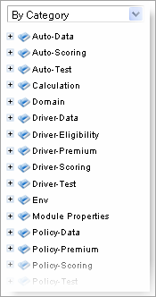  Figure 3: Module tree sorted by category  The By Category Detailed view displays modules sorted by the first value of the Category property. In the example the same module tree is sorted by Category Detailed. The modules that have the Auto-Data category are shown in the Auto node and Data sub-node. The modules with, for example, Calculation category value, are displayed in the Calculation node, Calculation sub-node:  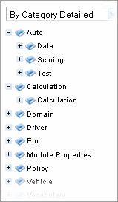  Figure 4:Module tree sorted by Category Detailed  An example below provides the module tree sorted by Category Inversed (where the modules are sorted by the second value of the Category property):  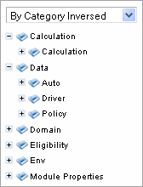  Figure 5:Module tree sorted by Category Inversed  Note: If in a Properties table ‘scope’ is defined as ‘Module’ then in the By Category view this table is shown in the Module Properties sub-node (see illustration above). If the ‘scope’ is defined as ‘Category’ then the table will be displayed in the Category Properties sub-node.  OpenL Tablets WebStudio hides various technical table details when a table is opened in simple view. The following is an example of a table opened in simple view:  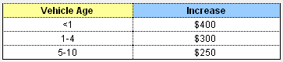  Figure 6: Rule table in simple view  The user can switch to the simple view by clicking the View button and deselecting the Header check box.
Extended view | Project is displayed in a way convenient to experienced users with module tree elements organized by type rather than logically. The following is an example of a module tree displayed in extended view and sorted by type:  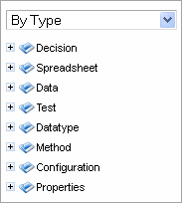  Figure 7: Module tree sorted by type  The following module tree is sorted By File and by spreadsheets within the file:  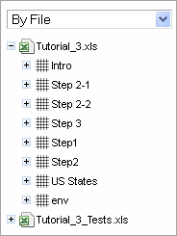  Figure 8: Module tree sorted by file  OpenL Tablets WebStudio shows various technical table details important for integration with code when a table is opened in extended view. The following is an example of a table opened in extended view:  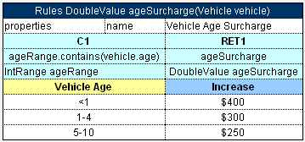  Figure 9: Rule table in extended view  User can switch to extended view by clicking the View button and selecting the Header check box.

Repository Editor
Repository editor provides controls for browsing and managing Design Repository. User can switch to repository editor by clicking the Repository control. Repository editor resembles the following:
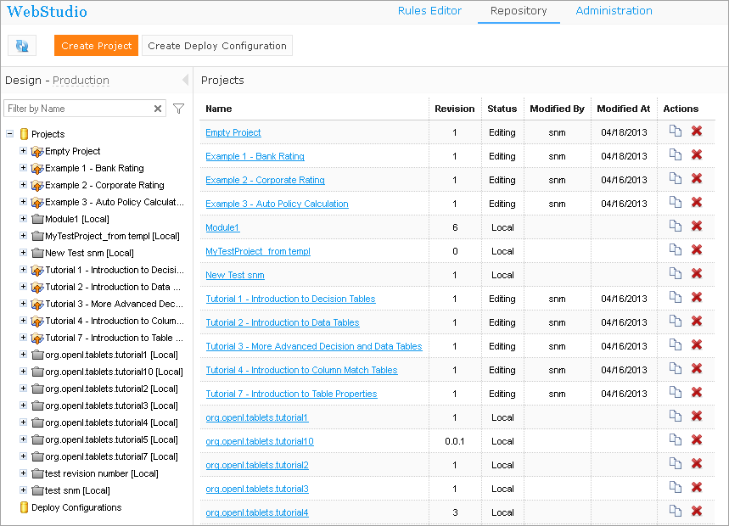
Figure 10: OpenL Tablets WebStudio repository editor
The left pane contains a tree of projects stored in Design Repository and user's workspace. Unlike Rules Editor, repository editor displays physical project contents in terms of files and folders.
The right pane of repository editor differs depending on the element selected in the tree.
The user can switch to Rules Editor by clicking the Rules Editor control.
For detailed information on tasks that can be performed in repository editor, see Chapter 5: Using Repository Editor.

Chapter 3: Using Rules Editor
This section describes the basic tasks that can be performed in Rules Editor. For general information on Rules Editor, see Rules Editor.
The following topics are included in this section:
- Filtering Projects
- Opening a Module
- Managing Projects
- Viewing Tables
- Modifying Tables
- Performing a Search
- Creating New Table

Filtering Projects
The system enables you to limit a list of projects to be displayed in the Projects list. For that, you should start typing a project name in the field located above the list of projects.
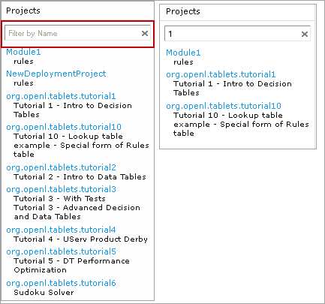
Figure 11: Filtering projects by Name
To get a full list of project, click the cross on the right.

Opening a Module
Rules Editor allows a user to work with one module at a time. To select a module, in the Projects tree select the module name. Selected module appears as a tree in the left pane displaying its tables. If a particular module is not available, the project in which it is defined must be opened. For information on opening a project, see Opening a Project.

Managing Projects
This section explains the following tasks that can be performed on projects in Rules Editor:
- Editing and Saving a Project
- Reverting Project Changes

Editing and Saving a Project
A project can be opened for editing and saved directly from the Rules Editor.
If you want to have an open project in the Editing status, above the module tree, clicks Edit Project. If the project is edited, to save it, click Save Project.
NOTE: If the project is in the Local status these options are not available from the Rules Editor.

Reverting Project Changes
OpenL Tablets WebStudio provides functionality allowing users to compare and/or roll back module changes against a specific date.
To compare project versions, select the desired project in the Projects tree and follow the steps below.
- Click the Revert button in the top line menu. The Revert Changes page appears where all the project versions are displayed.
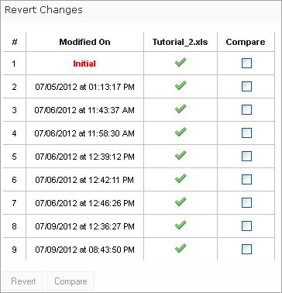
Figure 12: Compare / Revert project changes – Step 1
- To compare the changes, select checkboxes for the required dates and click the Compare button.
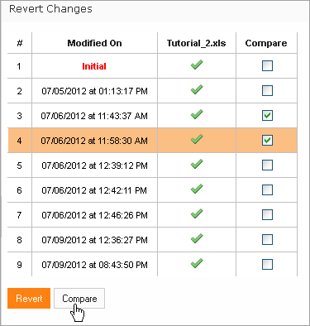
Figure 13: Compare / Revert project changes – Step 2
The system displays the project in a separate browser window where changed table(s) are marked as shown in the example below.
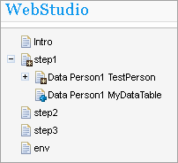
Figure 14: Table(s) with changes
- Click the change to be viewed. The comparison result will be shown in the bottom of the window.
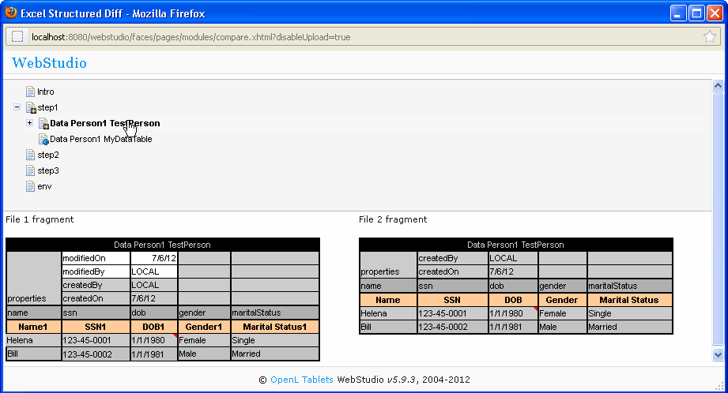
Figure 15: The result of the comparison
To revert module changes:
- Follow Step 1 and Step 2 described above.
- Click the Revert button under the list of changes.
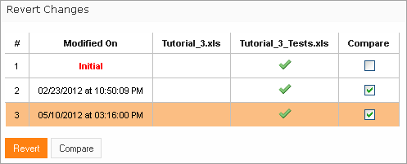
Figure 16: Revert project changes
- Click OK in the confirmation window.

Viewing Tables
OpenL Tablets module tables are listed in the module tree. Table types are represented by different icons in Rules Editor. The following table describes table type icons:
Table type icons
Icon | Table type
 | Decision table.
 | Decision table with unit tests.
 | Column match table.
 | Column match table with unit tests.
 | Tbasic table.
 | Tbasic table with unit tests.
 | Data table.
 | Datatype table.
 | Method table.
 | Unit test table.
 | Run method table.
 | Environment table.
 | Property table.
 | Table not corresponding to any preceding types. Such tables are considered comments.
 | Spreadsheet table.
For information on each table type, see OpenL Tablets Reference Guide. If a table contains an error, a small red cross is displayed in the corner of the icon.
To view contents of a particular table, in the module tree, select the table. The table is displayed in the middle pane. If the project is not in the Editing status, the table can be viewed but not modified.

Modifying Tables
OpenL Tablets WebStudio provides embedded tools for modifying table data directly in the web browser. To modify a table, proceed as follows:
- If the project is not in the Editing status, open it for editing as described in Editing and Saving a Project
- In the module tree, select the required table.
The selected table is displayed in the middle pane in the read mode.
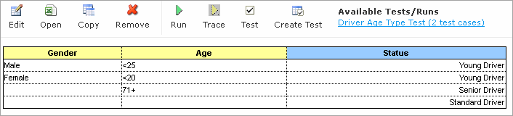
Figure 17: Table opened in OpenL Tablets WebStudio
- If required to switch between simple / extended view, click the View button at the top right of the screen and select / deselect the Header and/or Formula options.
- To switch the table to edit mode, perform one of the following steps:
- Above the table, click the Edit button
- Right-click anywhere in the table and click Edit
- Double click the cell to be edited
Note: The table cannot be switched to edit mode if the project is not in the Editing status.
Note: Alternatively, the file can be edited in Excel. In the local mode, the rule file is opened in Excel, and changes become available in OpenL Tablets WebStudio upon Excel file saving. In the remote mode, the file must be saved locally and after modifying, uploaded via the repository.
The following table is switched to edit mode.
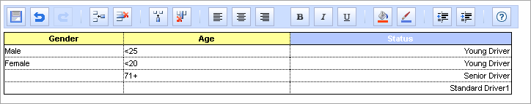
Figure 18: Table in edit mode
The edit mode provides the following buttons above the table:
Table editing buttons
Button | Description
 | Saves changes in table.
 | Reverses last changes.
 | Reapplies reversed changes.
 | Inserts a row.
 | Deletes a row.
 | Inserts a column.
 | Deletes a column.
 | Aligns text in currently selected cell with left edge.
 | Centers text in currently selected cell.
 | Aligns text in currently selected cell with right edge.
 | Make the text bold
 | Italicisize the cell text
 | Underline the cell text
 | Setl fill color
 | Set font color
 | Decreases indent.
 | Increases indent.
 | Opens help.
- Modify cell values as required.
A cell can be modified by double clicking it or pressing Enter while the cell is selected.
- To save changes, click Save .

Editing Range Data Types
OpenL Tablets WebStudio provides a special tool — range editor, — which helps you to add and/or edit range data types: IntRange and DoubleRange, — in rule tables and Test tables.
We start from brief description of Range Editor concepts and then consider a very simple example of how the tool works.
The main Range Editor goal is to move to a single range format in OpenL rules, namely, the ‘..’ format. You can find detailed information about ranges on OpenL Tablets in the Range types in Openl section of the OpenL Tablets Reference Guide document. While working with Range Editor, take into account the following.
- The default range format is set to ‘..’ in OpenL Tablets WebStudio.
- If you create a new range, the ‘..’ format will be used.
- If you edit a range format other that ‘..’, your format will remain the same in case you only edited values of the range. If you use any control in the editor, i.e. a checkbox, or the Done button and so on, the range format will be changed to ‘..’.
As an example, assume we have a Decision Table with some data represented as range like the following one.
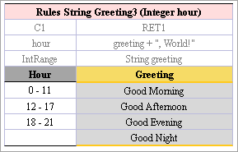
Figure 19: Decision Table with a Range Data type
In this table, the Hour column contains hours with the IntRange Data type. All range sells are filled except for the last one. We will use this example to demonstrate how the Range Editor works.
Here is a list of controls available in the Range Editor:
- From — indicates the left border of the range.
- To — indicates the right border of the range.
- Include — indicates whether or not the border will be included to range.
- ‘>’ — indicates values more than the specified border
- ‘<’ — indicates values less than the specified border
- ‘=’ — indicates a constant
- ‘-’ — indicates a range
Follow the steps below to enter new range.
- Double click a cell you want to edit. For example, the cell containing 18-21. Your table extends by the following popup with a set of controls that allow editing the range.
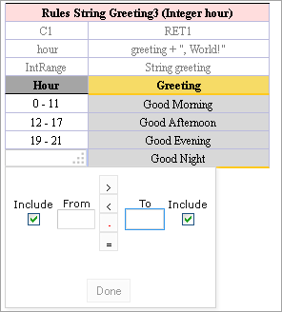
Figure 20: Create a range in Range Editor – step 1
- In the From field, enter the left border of the range, it is 22 in our example.
- In the To field, enter the right border of the range, it should be 24 in our example, but we will enter 23 to have a chance to edit this border later. And also let’s uncheck right Include. Note how your range looks in the form.
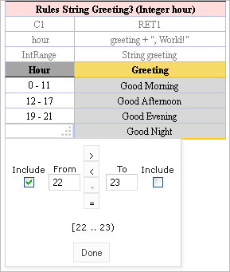
Figure 21: Create a range in Range Editor – step 2
- Click Done to complete. The last cell in the Hour column is filled as follows.
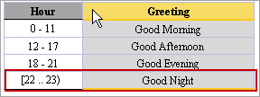
Figure 22: New range created in Range Editor
Now we will consider how to change a range with the Range Editor. We will start with the range created in the previous example and will change it to demonstrate how it works.
- Double click the cell with the [22-23) range. Your table looks like this one:
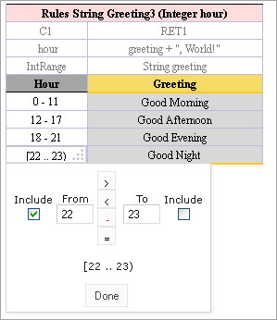
Figure 23: Edit a range in Range Editor
- Select the To field, set the right border to 24 and select Include. Click Done to save your work. Your range looks as follows.
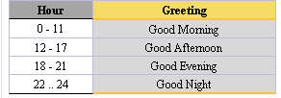
Figure 24: The range edited in Range Editor
You can also change your range by using ‘>’, ‘<’ and ‘=’ controls described above in this topic.

Copying Tables
If you need to create a table based on an existing one you can copy that table in one of the following ways.
- As a New Table
- As a New Version
- As a New Business Dimension Version
To create a copy as a new table
- Select a table you wish to copy in the module list.
- Click the Copy Table icon: . The system displays the Copy Table form with New Table selected by default:
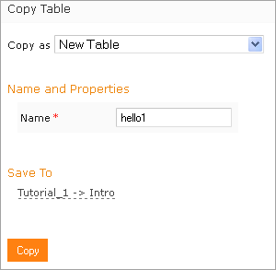
Figure 25: Creating a Copy as a New Table
- Update the Name field (optional).
- If you want to change the workbook and worksheet where the copy is to be saved click the link in the Save To area.
- Select the desired module and category from the corresponding drop down lists. You can also choose to save your copy in a new category using the New option.
- Click Copy to save your changes. The table appears in the module list.
Copying a table as a New Version is described in details in the Copy as New Version section. In that case dimensional properties of a new version are exactly the same as for the original one. OpenL Tablets allows you to create an overloaded table from an existing one.
To a copy as a New Business Dimension version:
- Click the Copy Table icon for the selected table in the module list.
- Select New Business Dimension Version in the Copy as list.
- Enter business dimension properties as you need.
- Change or leave the same workbook and worksheet in the Save as area.
- Click Copy to save your work.

Performing a Search
OpenL Tablets WebStudio provides search functionality allowing users to perform a search across data in all module tables for a particular project.
There are the following search modes in the WebStudio application:
- Simple Search
- Advanced Search

Simple Search
Simple search looks for a particular word or phrase in all tables within a given module.
To perform a simple search, enter a word or phrase you are looking for into the Search field and click .
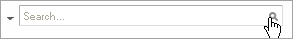
Figure 26: Starting the simple search
OpenL Tablets WebStudio displays all the tables containing the entered text. Above each table there is the Open Table in Excel link redirecting to the Excel file containing the entered text; the Edit Table link opens the table in Rules Editor with the possibility to edit that table.
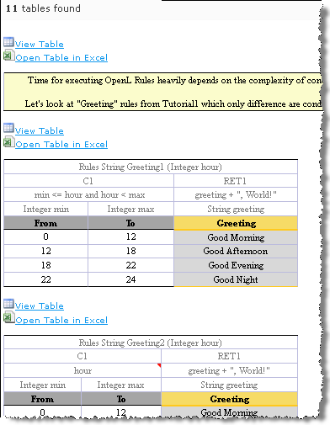
Figure 27: Search results
You can also use simple search to look for any cell content by right-clicking a cell (the table should be open in read mode) and selecting the Search item in the context menu.

Advanced Search
Advanced search allows the user to narrow the search by specifying criteria for tables where the search is to be performed. You can limit the search by specifying one or more table types, text from the table header and table properties as described below.
- To start advanced search, click the arrow to the left of search window.
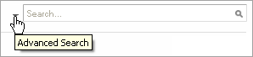
Figure 28: Advanced Search – Step 1
- In the filter form, click in the Table Types field and select the desired type of table or mark Select All to search in all table types.
- In the Header contains field, enter the word or phrase you are looking for.
- Expand the Table Properties list and select the table property you need and then click the Add button on the right. The text field appears where you should enter the property name.
- Enter the property name.

- Proceed the same way to add more table properties if required. To remove the property you don’t need, click the cross at the right of the property.
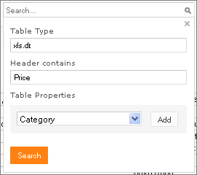
Figure 29: Advanced Search – the filled form
- Click the Search button to run the search.
As a result, the system displays the tables matching the search criteria along with a link to the relevant Excel file and the Edit Table link leading to the table editing page.
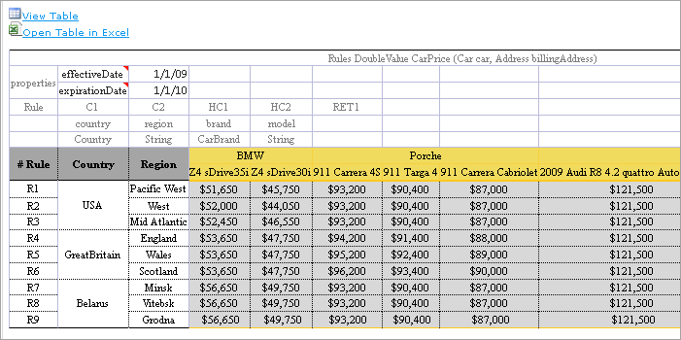
Figure 30: Advanced Search result

Creating New Table
OpenL Tablets WebStudio allows creating new tables of the following types:
- Datatype table
- Datatype Alias table
- Data table
- Test table
- Properties table
- Simple Rules table
To open the table wizard page, click the Create Table button:. By using the wizards, you will normally create a table for a current module. If your project contains included modules, the table is available from all that modules, as well as for all the modules linked by dependencies. (See the Module dependencies section in OpenL Tablets Reference Guide for more information on dependencies.)

Datatype Table Wizard
To create new Datatype table, follow these steps:
- Select the Datatype Table item as shown in picture below and press the Next button.
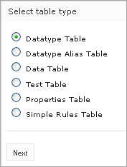
Figure 31: Table wizards
- On the next screen, enter the name for your new data type in the Name text box. You can also select an existing data type in the Parent type drop down list if needed. In this case, your data type will have access to all fields defined in the parent data type. (See the Inheritance in Data types section in OpenL Tablets Reference Guide for details.) This option is unavailable if no custom data types are available in the module.
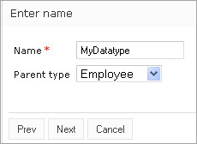
Figure 32: Datatype table wizard – Step 1
- Define the data type fields. To add more types, click the Add parameter link. Click Next to proceed.
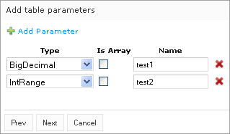
Figure 33: Datatype table wizard – Step 2
- On the next page, indicate where your new Datatype table should be located. For that, define the module to which the new table belongs. If there are included modules in the project you will see all of them in the Module drop down list. In the Category area, select an existing sheet or specify a new one in the New text box.
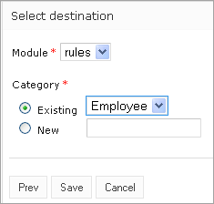
Figure 34: Datatype table wizard – Step 3
- Click Save to complete. Your new Datatype table will be created and available in the OpenL Tablets WebStudio.

Data Table Wizard
Creating a Data table in WebStudio is similar to creating a Datatype table described in the previous section except for several steps described in this section in details.
- Select the Data Table item in and click Next to proceed.
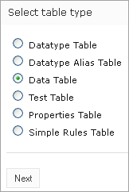
Figure 35: Data Table wizard - Step 1
- From the Type list, select the table Type; enter the table name in the Name text box.
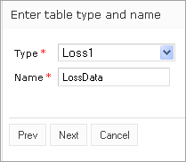
Figure 36: Data Table wizard – Step 2
- Define the table columns configuration. In our example we create Data table for the custom Data Type ”Loss1” so the screen will look similar to the next one.
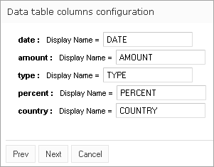
Figure 37: Data Table wizard – Step 3
- Indicate where your new Data table will be located. For that, define the module to which the new table belongs. If there are included modules in the project you will see all of them in the Module drop down list. In the Category area, select an existing sheet or specify a new one in the New text box.
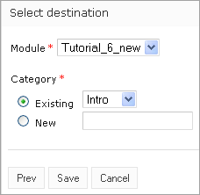
Figure 38: Data Table wizard – Step 4
- Click Save to complete your work.
From that point your new Data table is created and you can enter data and modify the table as needed.

Simple Rules Wizard
This section describes how to create a new Simple Rules table in OpenL Tablets WebStudio.
- Click the Create Table button and, select Simple Rules Table in the Select table type list and click Next:
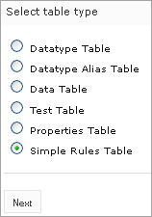
Figure 39: Simple Rule Table wizard – Step1
- In the next screen, enter your table name in the corresponding field, select the desired Data type in the Return Value Type drop down list and click Add Input Parameters. The following form appears.
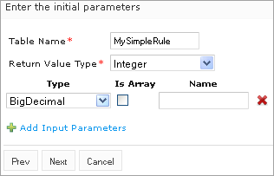
Figure 40: Simple Rule Table wizard – Step 2
- Specify input parameters for your table and click next to proceed:
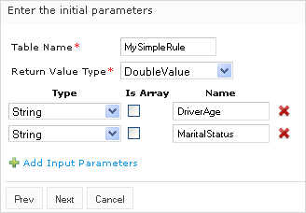
Figure 41: Simple Rule Table wizard – Step 3
- In the next screen you get a blank Simple rule table with the header constructed based on your previous steps. Now you can fill in the table with your data as explained in the Tips box.
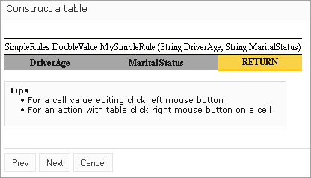
Figure 42: Simple Rule Table wizard – Step 4
- In the next step you can do one of the followings by selecting appropriate option from the list:
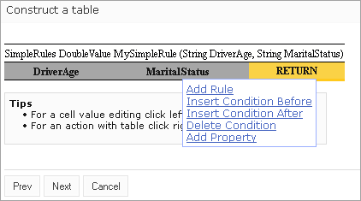
Figure 43: Simple Rule Table wizard – Step 6
Add Property — The properties row appears where you can select property from drop down list and indicate their values.
Add Rule — A new empty row appears allowing you to enter the data as you want, like in the example below:
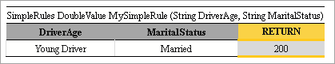
Figure 44: Simple Rule Table wizard – Step 7
You should repeat until add as many rows as required.
Insert Condition Before / Insert Condition After — Condition column will be added in the specified position. In the following example the DriverOccupation condition column was added.
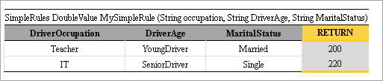
Figure 45: Simple Rule Table wizard – Step 8
Delete Condition / Delete Rule — You can remove your condition /rule if required.
- Click Next after all information is added. The Select destination screen appears where you should indicate where your new Simple Rule table will be located. For that, define the module to which the new table belongs. If there are included modules in the project you will see all of them in the Module drop down list. In the Category area, select an existing sheet or specify a new one in the New text box.
- Click Save to save your work. Your new Simple Rules table is created and available in your project.

Chapter 4: Editing and Testing Functionality
This section provides an overview of more advanced OpenL Tablets WebStudio functions.
The following topics are included in this section:
- Editing Tables
- Unit Tests
- Tracing
- Benchmarking

Editing Tables

Editing comma array values from UI
A multi selection window, displaying all values, appears when editing the field defined as an array via commas.
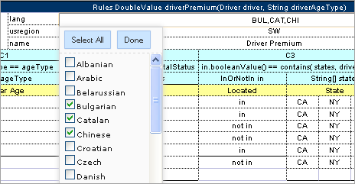

Figure 46: Multi editor in WebStudio for editing comma separated arrays

Editing Table Properties
This section describes table properties available in OpenL Tablets WebStudio. For detailed information on table properties refer to OpenL Tablets Reference Guide, section Table Properties.

Default Properties
If default property values are defined for a table they appear only in the right hand Properties section, but not in the table. In the example below, there are Active = true and Fail On Miss = false default properties.
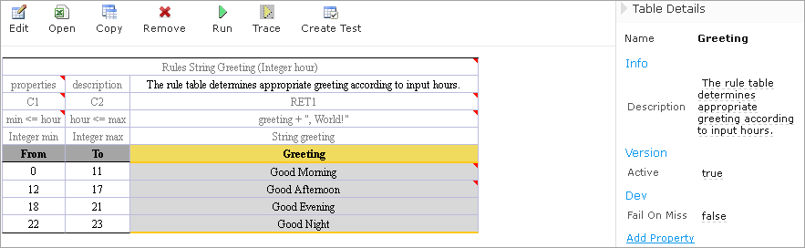

Figure 47: Default table properties example
Default properties can be overridden at the table level; in the other words you can change them as follows.
- In the Properties section, click the default property to be changed. Instead of the property value you will see a checkbox:
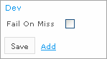
Figure 48: Updating a default property
- Select or deselect the checkbox as needed and click the Save button. The property appears in the table with its new value:
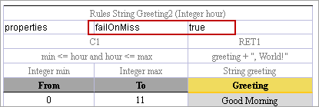
Figure 49: Default property was updated by a user

Inherited Properties
Module or category level properties are those inherited from a Properties table (See OpenL Tablets Reference Guide, section Properties Table for details). In the Properties section of a given table, inherited properties appear in a different color and are accompanied with a link to the Properties table where they are defined. The values of inherited properties are not stored in the table, they are displayed in the Properties section, since they are inherited and applied to this table. Inherited properties can be overridden at a Table level, i.e. you can change them.
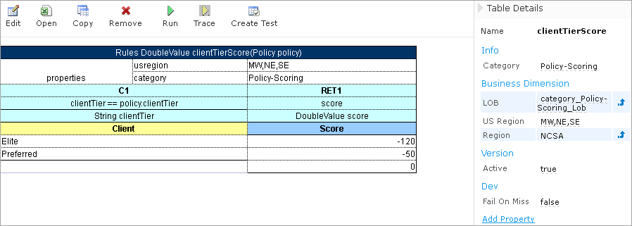

Figure 50: An example of inherited category-level properties
To change an inherited property, follow these steps:
- In the Properties section, click the inherited property to be changed
- Enter or select from drop down list the desired value(s) and click the Save button:
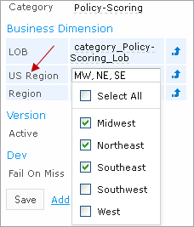
Figure 51: Updating an inherited property
The system displays the property in the table:
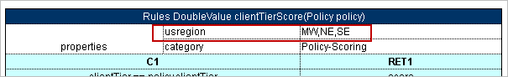
Figure 52: Inherited category-level property was updated by a user

System Properties
By default, OpenL Tablets WebStudio applies system properties to each created or edited table. If you want to switch off this option, please refer to the Common Settings section for instructions. The values of System properties are provided in the table and in the Properties section.
The “modifiedBy” property value is set using the name of the currently logged in user. The “modifiedOn” property is set according to the current date. These properties are applied upon each save and cannot be edited in the UI.
The “createdBy” property value is set using the name of the currently logged in user. The “createdOn” property is set according to the current date. These properties are only applied in the Multi mode (See Security Overview for details) on the first save only while creating or copying a table in OpenL Tablets WebStudio. The WebStudio users can delete those properties if required.
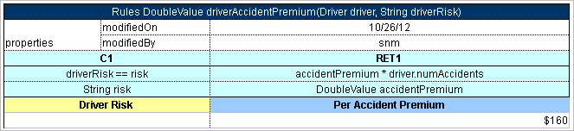

Figure 53: An example of system properties

Properties for a Particular Table Type
Some properties are only applicable to particular types of tables. When you open a table in OpenL Tablets WebStudio the properties section displays properties depending on the type of the table.
For example, such properties as Validate DT or Fail On Miss are available for Decision Tables. That means you can select them from the drop down list after clicking the Add link in the bottom of the Properties section. The Figure below shows that properties applied to a Decision Table.
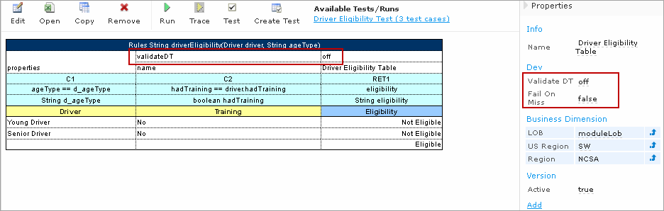

Figure 54: Properties for the Decision table type
If you open a Data Table in the same project, these properties will not be available for selecting from the drop down list in the Properties section.
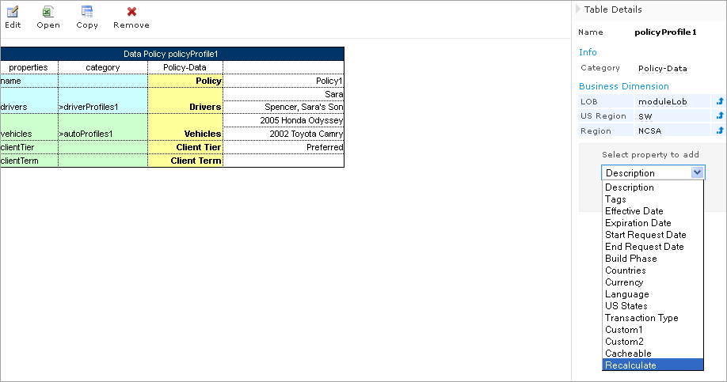

Figure 55: The Decision table properties that are not available for a Data table
When doing action 'Copy', properties not suitable for current table type, don`t appear in the wizard.
To add a new property for the selected table, follow the steps below.
- Click the Add link in the Properties pane:
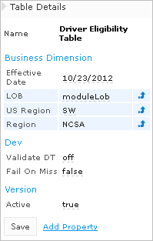
Figure 56: Add new property for the current table
- Enter the desired property or select it from drop down list and click the Add button.
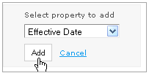
Figure 57: Selected table property to be added
- Specify the property value, and then click the Save button to complete. All the steps are collected in the Figure below.
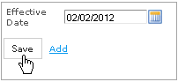
Figure 58: Saving a new property for the current table

Copy as New Version
The table versioning mechanism is based on copying the existing table and is initiated in OpenL Tablets WebStudio by clicking the Copy button. Then you should select New Version in the Copy as list, enter the data as needed and click Copy to save your work.
A new table version has the same identity, that is, signature and dimensional properties of the previous version. When a new table version is created, the previous version becomes inactive since only one table version can be active at a time. By default, all tables are active. Below is an example of an inactive table version.
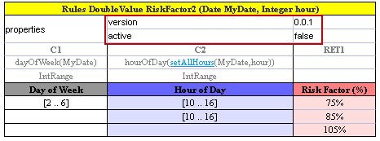

Figure 59: An inactive table version
Versions of the same table are grouped in the module tree under the table name. Clicking the table name displays the active version. If all tables are set to inactive, the latest created version is displayed.
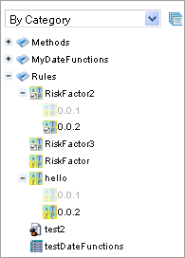

Figure 60: Displaying table versions in the module tree
The table version is defined in three digit format, such as 4.0.1. Table versions must be set in an increasing order.
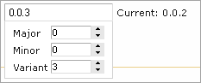

Figure 61: Entering a new version number

Unit Tests
Unit tests are used in OpenL Tablets to validate data accuracy. OpenL methods with predefined input data compare the test results with expected results. Every decision table can be accessed as an OpenL method. The method signature is included in the header of a decision table. Each unit test is stored in a separate table.
For example, in the following diagram, the table on the left is a decision table but the table on the right is a unit test table that tests data of the decision table:
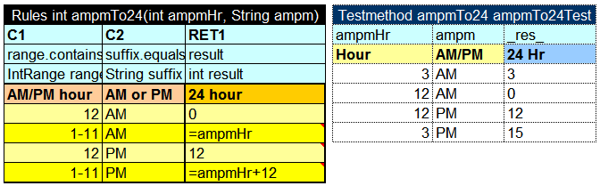
Figure 62: Decision table and its unit test table
OpenL Tablets WebStudio supports visual controls for creating and running project unit tests. Unit test tables can be modified like all other tables in OpenL Tablets WebStudio. For information on modifying a table, see Modifying Tables. Test results are displayed in a simple format directly in the user interface.

Navigation
WebStudio adds to table view navigation link to appropriate test table and vice versa. See below.
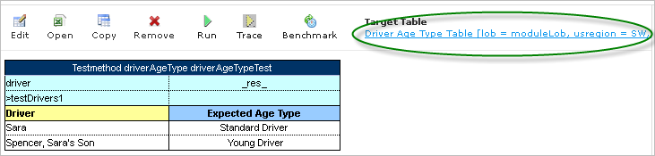
Figure 63: Navigation link to target table

Run Tests
This section provides the methods used to run unit tests.

Execute all project tests at once
The system automatically executes all test runs in every unit test in project and displays a summary of results.
To run all project tests, click the Run All Tests icon above the project tree in Rules Editor.
Test results resemble the following:
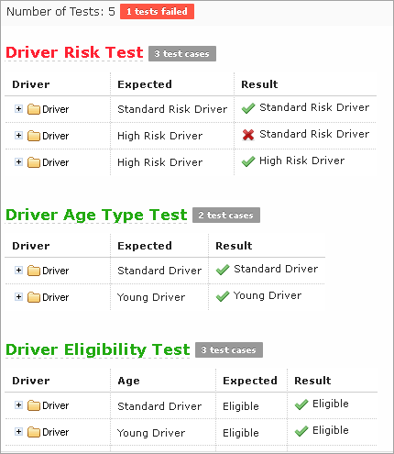
Figure 64: Results of running all project tests
Failed tests are represented by mark. Passed tests are represented by mark.

Execute tests for a single table
To execute all test runs for one particular rule table, in Rules Editor, in the module tree, select the rule table and, in the upper part of the middle pane, click Test .
Test results resemble the following:
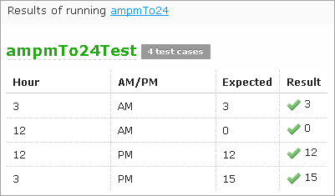
Figure 65: Results of executing all test runs for one rule table
You can also test a rule table even if no tests have been created for the given table yet. For that, follow the steps below.
- Select the desired rule table in the module tree and click the green Run arrow above the table. The form appears where you shall enter required values:
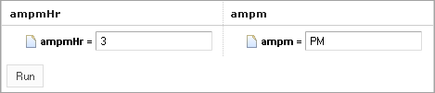
Figure 66: Testing a rule table without tests
- Click the Run button within the popup. The results of the testing are displayed:
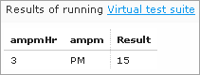
Figure 67: Result of running virtual test
For Test tables, the system enables you to select test case(s) to be executed.
- Navigate to the Run button above the Test table and click the small black arrow:
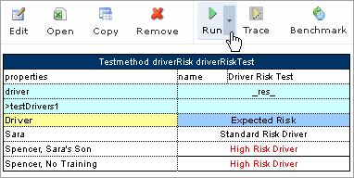
Figure 68: Running test cases with selection for a Test table
- The popup appears where you can choose from the test cases; select or clear the check-boxes as you need:
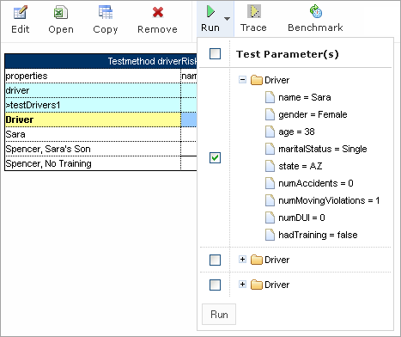
Figure 69: Select test cases to be executed
- Click the Run button within the popup. Only selected test cases will be executed:
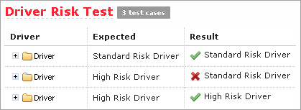
Figure 70: Result of selective testing

Creating New Test
WebStudio provides convenient way to create a new test table.
After you have created executable table (Decision, Method, Test, Run, Spreadsheet) the Create Test item will be available.
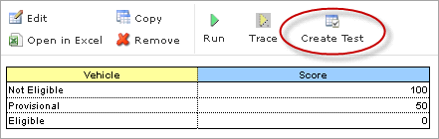
Figure 71: Create new test table
Click the Create Test button to create Test table for current table. WebStudio proposes you the two step wizard which helps to create appropriate Test table.

Tracing
OpenL Tablets WebStudio provides a rule tracing view for all appropriate OpenL Tablets methods. These methods include the following:
- All unit tests
- All Rule tables with the possibility of specifying input parameters and tracing any method
- Run Method tables with preset parameters
Rule tracing enables users to determine how results for complex rules are obtained.
IMPORTANT! Make sure your browser does not block pop-up windows. Otherwise, you will not see the trace results. See information on how to make this setting in your browser Help.
Using the tracing functionality you can check the result of each step of the rule and how the result was obtained without creating test cases. For that, follow the steps below.
- In Rules editor, open a rule table you want to trace and click Trace in the middle pane.
- Enter parameters to be traced in the popup window:
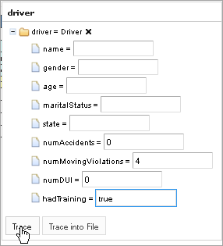
Figure 72: Tracing a rule for a rule table
- Click the Trace button.
If you have a set of test cases and want to check the result of each step of the rule and how the result was obtained, you can trace the Test table as follows.
- Open the desired Test table and hover the mouse pointer over the Trace button.
- Click the small right-hand black arrow to open a popup with test cases to be traced.
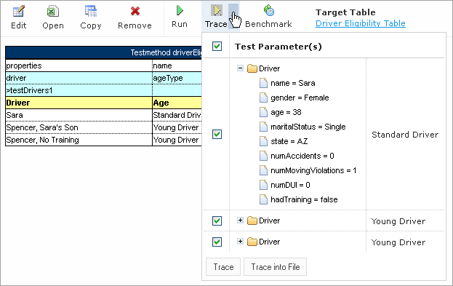
Figure 73: Run tracing for a Test table
- In the popup, select or deselect the test cases as you need. By default, all the cases are selected. You can also check or uncheck all test cases by using the checkbox on the left of Test Parameter(s).
- Click Trace to start the process. The system displays the tracing results in a separate browser window as illustrated below.
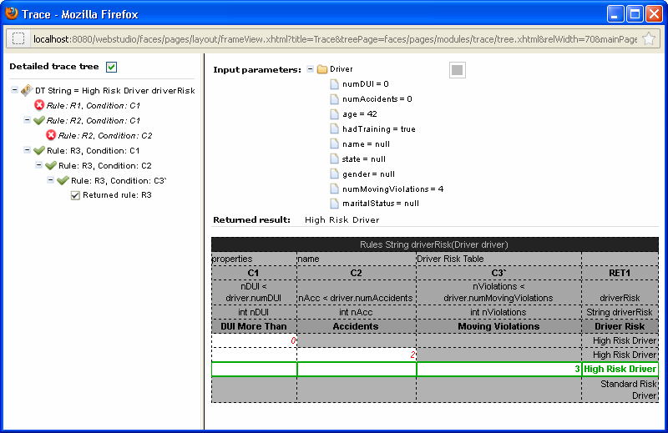
Figure 74: Tracing results
The left side displays a tree consisting of rule table(s) as tree nodes and fired rule rows as tree leaves. Selected Detailed trace tree option enables you to view all method calls. If you clear that option only successful calls will be displayed. This option can only be used for a Decision table or if a Decision table is used in a complex rules.
If an element in the tree is selected, the corresponding rule table is displayed in the right pane. The fired rule rows are highlighted using the specified color. The highlight color and transparency level can be configured by clicking the button above the rule table (the button is gray by default).
In addition the right pane displays the actual parameters used in the particular method call and the returned result.
The example above demonstrates the results of tracing Decision table. For other rule tables, the picture differs a bit but the meaning is essentially the same.
For a Decision table the tracing results are shown as follows:
- The rules that were traced are not highlighted (white rows)
- Successfully completed (returned) rules are boxed with green lines
- The failed rules are displayed in red

Benchmarking
OpenL Tablets WebStudio provides benchmarking tools for measuring execution time for all appropriate OpenL Tablets elements. In OpenL Tablets, everything that can be run can be benchmarked too. Benchmarking is useful for optimizing the rule structure and identifying critical paths in rule calculation.
The benchmarking icon is displayed above a table to be traced.
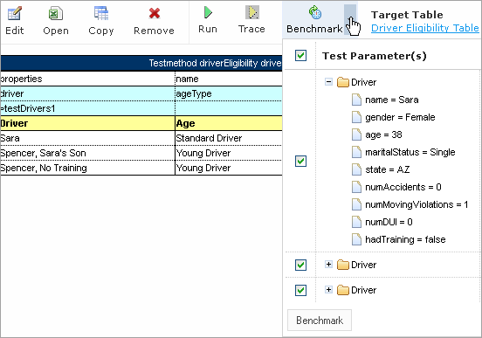
Figure 75: Controls for measuring performance
For a Test table, you can select the test cases as follows:
- Open the desired Test table.
- Navigate to the Benchmark button above the Test table and click the small right-hand black arrow to open a popup with test cases as you need.
- Select or deselect the test cases as you need. By default, all the cases are selected. You can also check or uncheck all test cases by using the checkbox on the left of Test Parameter(s).
- Click the Benchmark button within the popup.
Clicking the benchmarking icon runs the corresponding method or set of methods and displays the results in a table.
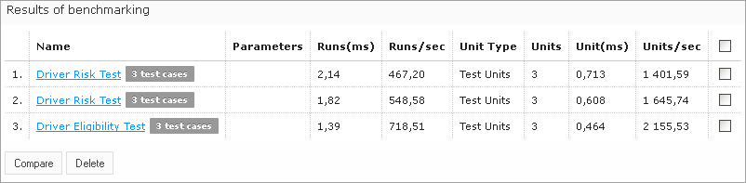
Figure 76: Benchmarking results
OpenL Tablets WebStudio remembers all benchmarking runs executed within one session. Every time a new benchmark is run, a new row is added to the results table.
Benchmarking results can be compared to identify the most time consuming methods. Select the required check boxes and click Compare to compare results in the results table.
Comparison results are displayed below the benchmarking table.
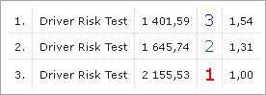
Figure 77: Comparing benchmarking results

Chapter 5: Using Repository Editor
This section describes tasks that can be performed in repository editor. For general information on repository editor, see Repository Editor.
The following topics are included in this section:
- Browsing Design Repository
- Filtering the Project Tree
- Creating Project in Design Repository
- Opening a Project
- Closing a Project
- Editing a Project
- Saving a Project
- Defining Project Dependencies
- Modifying a Project
- Copying a Project
- Removing a Project
- Deploying Projects
- Comparing Project Versions

Browsing Design Repository
Repository editor displays all projects in user's workspace and Design Repository. The project tree is organized into the following categories:
Categories in the project tree
Category | Description
Projects | Contains OpenL Tablets rule projects.
Deploy Configurations | Contains deploy configurations for deploying rule projects to Production Repository. For information on using deploy configurations, see Deploying Projects.
The status of each project in the tree is identified by a specific icon. The following table describes the icons in the project tree:
Project icons in repository editor
Icon | Description
Project is closed.
It is available only in Design Repository and must be opened to copy it to user's workspace.
Project is opened.
It is copied to user's workspace in read only mode and must be moved to the Editing status for modification.
Project is edited by the current user.
It is copied to user's workspace and can be modified. Other users cannot edit the project. To save changes, the project must be saved.
Project is closed by the current user but edited by another user (Closed - Locked).
Current user cannot edit the project.
Project is opened by the current user but edited by another user (Opened - Locked).
Current user cannot edit the project but can browse the project in the Rules Editor.
Project exists only in user's workspace but not in Design Repository (Local).
Other users do not see this project. User can delete the project or import it into Design Repository as described in the Creating Projects in Design Repository section.
Project is marked for deletion.
In OpenL Tablets WebStudio, deletion of a project takes place in the following phases:
Phase | Description
Deleting a project | Project is removed from user's workspace and marked for deletion. In this phase, the project can be restored using the undelete function.  For information on deleting a project, see Deleting a Project.
Erasing a project | Deleted project is permanently removed from Design Repository. After this phase, the project cannot be restored.  For information on erasing a project, see Erasing a Project.

Filtering the Project Tree
You can filter projects in the Repository editor the same way as in the Rules Editor. To filter projects by name, just enter the name in filter text box. All projects matching the name will be displayed in the Projects list.
An advanced filter can be also applied to the project tree so that only files of particular types are displayed.
- Click the Advanced Filter icon to the right of the filter text box.
- In the Advanced Filter pop up window, enter a list of file extensions, separated by semicolon as follows:
xls;properties;txt
- Select the Hide deleted projects option if required.
- Click Apply.
The project tree is filtered so that only files of the specified extensions are displayed. Project folders are always displayed.
Note: To reset the filter, the user must clear the previously entered file extensions and click Apply.

Creating Projects in Design Repository
OpenL Tablets WebStudio allows users to create new rule projects in the Design Repository in one of the following ways:
- Create an new rule project from template
- Create a rule project from Excel file(s)
- Create a rule project from zip archive
- Import a rule project from workspace
Whatever the way used, new projects will be created in the Editing status that means they are open and can be modified.

Create a Project from Template
This is the easiest way to create a rule project in the Design Repository that should preferably be used for demonstration or introductory purposes.
While creating a project from template, you can use the following template types.
Simple Templates that include:
- Sample Project — a very simple project which consists of one rule table (and hence, one Excel file)
- Empty Project — allows you to create a project with empty Excel file. You can then open the project and create tables as you need.
Examples — provide several quite simple projects demonstrating how OpenL Tablets can be used in various business domains.
Tutorials — a number of projects designed to familiarize you with OpenL Tablets step-by-step, taking you from simple features and concepts to more complex ones.
You can use projects represented as Examples and Tutorials not only to learn how they are organized and work but also to create your own projects from them.
To create a new project from template, proceed as follows:
- In the top line menu, click Create Project.
The Create Project from window appears.
- Clicks the Template tab (this tab is normally selected by default). All project templates are organized into three areas: Simple Templates, Examples and Tutorials described above in this topic.
- Navigate to the desired template and click its name. The name appears in the Project Name field. An example below demonstrates creating a Simple project.
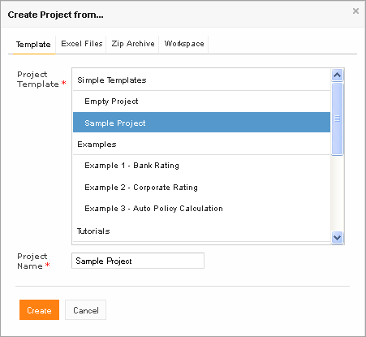
Figure 78: Creating Simple project from template
You can use the name provided or enter your own if you want.
- Click Create. A new project is created in Design Repository. Initially, project structure corresponds to selected project template but can be constructed manually.
- To construct the project structure, add folders and upload files as described in Modifying Project Contents.

Create a Project from Excel File(s)
You can create a rule project in the Design Repository by loading one or more Excel files that contain OpenL rule tables or entire rule projects. For that follow the steps below.
- Click Create Project in the top line menu.
- In the Create Project from dialog, click the Excel Files tab. The Create Project dialog will look as follows:
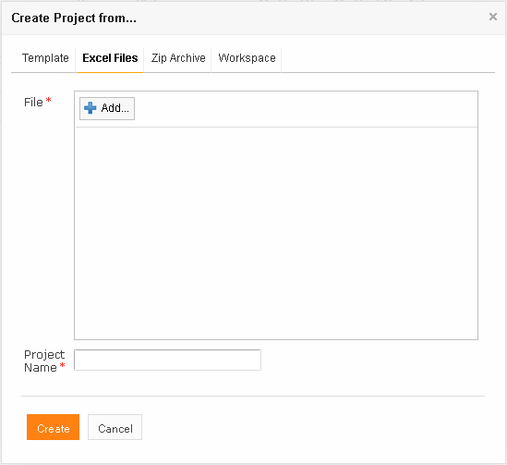
Figure 79: Creating a project from Excel file
- Click the Add button, locate the desired Excel file in a file system and click Open.
- If required, repeat the previous step to add more file(s) for your project. All the files will be listed in the File area.
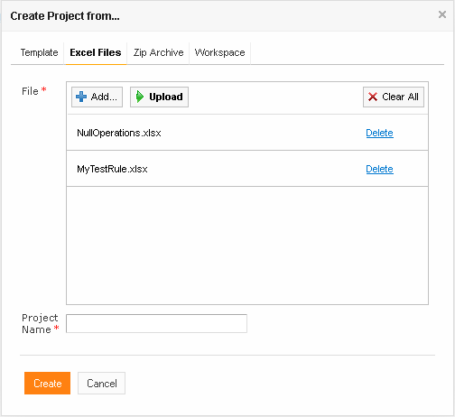
Figure 80: Excel files ready to be uploaded into Design Repository
You can remove any file from the list by clicking the corresponding Delete link or delete all of them by clicking Clear All.
- After adding all the files you want, click Upload to load the files into the repository. You can also upload each file separately but we do not recommend you to follow that way.
- In the Project Name field, enter the name by which the project must be represented in the Design Repository.
- Click Create to complete.

Create a Project from ZIP Archive
OpenL Tablets WebStudio provides a control for loading rule project(s) archived in a ZIP file into Design Repository. The procedure is similar to creating a project from Excel files described above although there are a few differences.
- Click Create Project in the top line menu.
- In the Create Project from dialog, click the Zip Archive tab.
- Click the Add button, locate the desired zip archive and click Open. You will see the file in the File area.
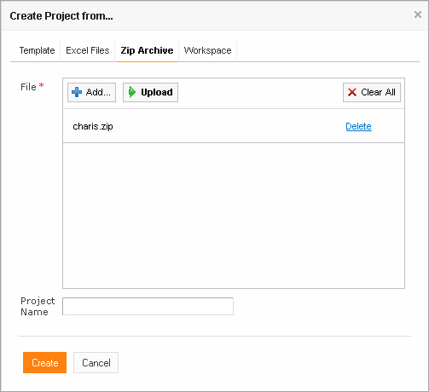
Figure 81: Creating a project from ZIP file
- Click Upload to proceed. The file name appears in the Project Name text box.
- Click Create to complete.

Import a Project from Workspace
You can create a new project in the Design Repository by loading a project with the Local status from user workspace.
- Click Create Project in the top line menu.
- In the Create Project from dialog, click the Workspace tab. The system displays rule projects available in your workspace:
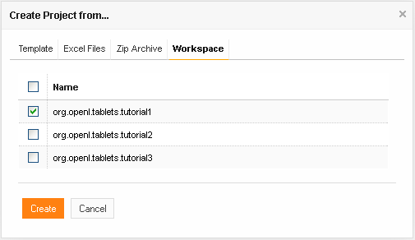
Figure 82: Creating a project from Workspace
- Select checkboxes for projects to be uploaded and click Create to complete.
In case project(s) are loaded successfully appropriate notification will be shown.

Opening a Project
An opened project is copied to user's workspace and becomes available for selection in Rules Editor. An opened project cannot be modified, it must become Editable as described in Editing a Project for modification.
To open a project, in the project tree, select the project and, in the right pane, click one of the following buttons as required:
Buttons for opening a project
Button | Description
Open | Opens the latest revision of project.
Open Revision | Displays window where user can specify which project revision must be opened.
You can also open any project revision from the Revisions tab. For that, select the project in the Projects tree and proceed as follows:
- Click the Revisions tab. A list of revisions appears.
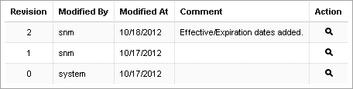
Figure 83: List of project revisions
- Navigate to the revision you want to open and click the corresponding magnifier icon in the Action column.
- Click OK in the information message.

Closing a Project
Closing a project deletes it from user's workspace. No changes you have made to the project will be applied and stored. From that point, the project is not available for selection in the Rules Editor. Users can still browse closed projects in the Repository Editor.
To close a project, in the project tree, select the project and, in the right pane, click Close.

Editing a Project
An editable project (the project status is Editing) is copied to user's workspace, becomes available for selection in Rules Editor and can be modified. Only editable project can be modified in the Rules Editor. To apply changes made to a project, the project must be saved as described in Saving a Project.
To make a project editable, in the project tree, select the project and, in the right pane, click Edit.
The latest project revision is becomes editable even if the user previously opened an older project revision.
Alternatively, an opened project can be made editable directly from Rules Editor as described in Editing and Saving a Project.

Saving a Project
A modified project is saved and copied from the user's workspace to Design Repository as a new revision.
To save a project, proceed as follows:
- In the project tree, select the project, and, in the right pane, click Save.
The Save changes window appears.
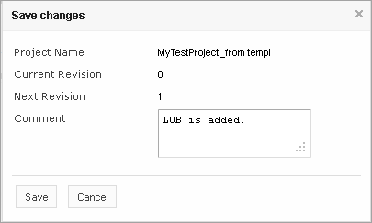
Figure 84: Save changes in a project
The number of a revision is updated automatically and specified in the Next Revision field.
- Enter comments if you need and click Save.
An editable project can be saved and closed directly from Rules Editor as described in Editing and Saving a Project.

Defining Project Dependencies
A project dependency can be defined when a particular rule project depends on contents in another project. Project dependencies are checked when projects are deployed to Production Repository. OpenL Tablets WebStudio displays warning messages when a user deploys projects with conflicting dependencies.
To define a dependency on another project, proceed as follows:
- If the project is not editable, make it editable as described in Editing a Project.
- In the project tree, select the project, and, in the right pane, select the Dependencies tab.
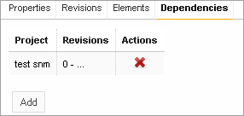
Figure 85: Project dependencies
The Dependencies tab lists all projects required by the selected project.
- To define a new dependency, click Add.
The Add dependency window appears.
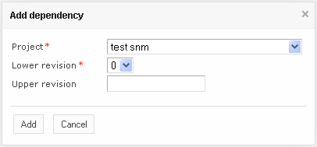
Figure 86: Defining a new dependency
- In the Project list box, select the required project.
- In the Lower revision list box, select the oldest allowed revision of the referenced project.
- Optionally, in the Upper revision field, enter the latest allowed project revision.
If the Upper revision field is empty, any project revision above the one specified in the Lower revision field is allowed.
- Click Add.
- Repeat this procedure to add as many dependencies as required.

Modifying a Project
For an editable project, users can modify the project’s properties and content.
The following topics are included in this section:
- Modifying Project Properties
- Modifying Project Contents

Modifying Project Properties
Each rule project has a set of properties displayed in the Properties tab when a project is selected.
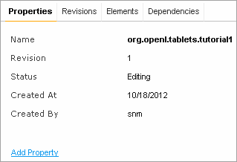
Figure 87: Project properties
Some properties such as Name, Crated At / Created By, etc are updated automatically by the system, and users cannot edit them in the WebStudio UI. The others can be specified for editable projects using the Add Property link as described in the next section.

Adding Business Dimension Properties
From OpenL Tablets WebStudio 5.9.4, users can add Business Dimension properties predefined in a drop down list.
Follow the steps below to add a Business Dimension property to a project.
- Select the project in the Projects tree.
- In the Properties tab, click the Add Property link.
- Select the desired property from the drop down list and click Add:
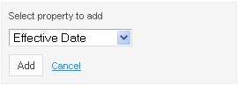
Figure 88: Add a project property
- Specify the value as you need and click the green tick on the right to save your changes:
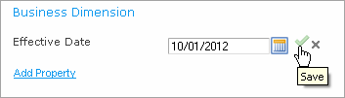
Figure 89: Save a new project property

Adding Custom Properties
The list of project properties available in the drop down list can be extended by adding Custom Properties. To add Custom properties, proceed as follows:
- Open the <tomcat directory>\webapps\webstudio\WEB-INF\conf\repository-artefact-props.properties file for editing.
- Enter the list of attributes to add to UI, delimited by comma, for example:
props.use = attribute1, attribute6, attribute7, attribute13
The following table describes types of attributes that can be added to UI:
Project properties that can be added to drop down list in UI
Property | Description
attribute 1 - attribute 5 | String properties.
attribute 6 - attribute 10 | Date properties.
attribute 11 - attribute 15 | Number properties.
- Uncomment the attributes to be added as Custom properties (remove appropriate ‘#’) and define the properties’ names, for example, as shown in this snippet:
props.attribute1 = Additional String Property
props.attribute7 = Additional End Date
props.attribute13 = Additional Number
If a property name is not defined, the property appears in drop down list and UI with its sequential number, such as attribute 6.
For example, if properties 1, 6, 7 and 13 are added, they appear in the drop down list as follows:
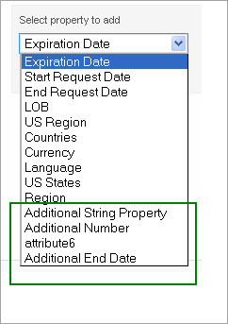
Figure 90: Customer properties 1, 6, 7 and 13 are shown in the green box
You will add Customer properties in the same way as described in the Adding Business Dimension Properties section above. The next Figure illustrates properties 1, 6, 7 and 13 as they appear in the project UI.
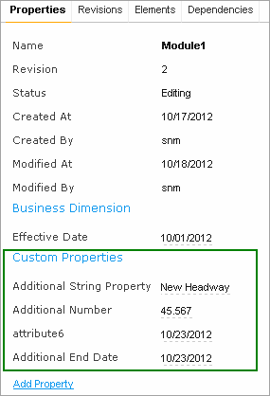
Figure 91: Project UI with properties 1, 6, 7 and 13 added

Modifying Project Contents
This section describes modifying the physical structure of the project.
The following topics are included in this section:
- Creating a Folder
- Uploading a File
- Deleting a Folder or a File

Creating a Folder
To create a new folder in the project structure, proceed as follows:
- If the project is not editable, make it editable as described in Editing a Project.
- In the project tree, select the parent folder in which the new folder must be created.
To create a root level folder, the project name must be selected in the project tree.
- In the right pane, click Add Folder.
- In the Add Folder window, enter the folder name and click Add.

Uploading a File
To upload a file to a project folder proceed as follows:
- If the project is not editable, make it editable as described in Editing a Project.
- In the project tree, select the folder where the file should be uploaded.
To upload a file to the root level, the project name must be selected in the project tree.
- In the right pane, click Upload File.
The Upload File window appears.
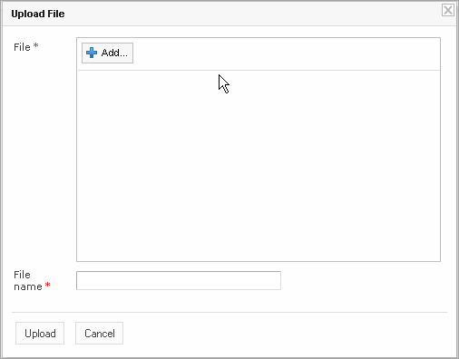
Figure 92: Uploading a file
- Click Add in the File area and select the file to be uploaded.
- Click the upper Upload button (with a green arrow).
- In the File name field, enter or modify the name of the file to be used in the Design Repository.
- Click the Upload button at the bottom.

Deleting a Folder or a File
To delete a folder or a file in the project structure, proceed as follows:
- If the project is not editable, make it editable as described in Editing a Project.
- Perform one of the following steps as required:
- Expand the project tree, select the folder or file to be deleted and, in the right pane, click Delete.
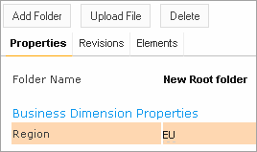
Figure 93: Deleting a project element
- If you want to delete an element inside the parent folder, select that folder, click Elements to expand the folder and then click Delete at the right of the item to be deleted.
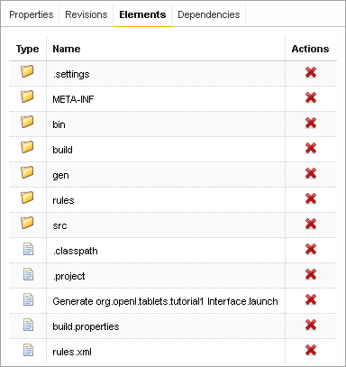
Figure 94: Deleting project elements from the Elements tab
- Click OK In the confirmation window.

Copying a Project
Copying a project creates a new project with identical contents and a different name in the Design Repository. This function can be used for copying local projects to the Design Repository with a different name.
To copy a project, proceed as follows:
- Perform one of the following steps as required:
- In the Projects tree, select the desired project and, in the right pane, click the Copy button.
- Click Projects in Navigator to get a list of projects, navigate to the project you want to copy and click the corresponding Copy item at the right.
- In the Copy Project window, enter the new project name and click Copy. Your new project appears in the list of projects in the Closed status.

Removing a Project
Removing a project is executed in the following phases:
- Deleting a Project
- Erasing a Project

Deleting a Project
A deleted project is removed from user's workspace and marked as deleted in Design Repository. All users can see that a project is deleted. Physically, it still remains in Design Repository.
NOTE: Projects that were not uploaded to the Design Repository (they have the Local status) will be removed physically and cannot be restored.
To delete a project, proceed as follows:
- Perform one of the following steps as required:
- In the Projects tree, select the project and, in the right pane, click Delete.
- Click Projects in Navigator to get a list of projects, navigate to the project you want to remove and click the corresponding Delete item at the right.
- In the confirmation window, click Delete or OK.
Deleted projects (except for those in the Local status) can be restored by using the Undelete button.
To make deleted projects visible uncheck the Hide deleted projects checkbox in the filter pop up window which appears after clicking the Filter button above the Projects tree and click Apply.
If you want to restore a deleted project:
- Navigate to the deleted project in the Projects tree.
- Click the Undelete button in the right pane.
- Click Undelete in the confirmation window.

Erasing a Project
Erasing a project permanently removes it from the Design Repository.
Warning: Erased projects cannot be restored.
To erase a project, proceed as follows:
- Delete the project as described in Deleting a Project.
- In the Projects tree, select the project and, in the right pane, click Erase.
- In the confirmation window, click Erase.

Deploying Projects
This section describes tasks related to deploying rule projects to Production Repository.
The following topics are included in this section:
- Creating a Deploy Configuration
- Defining Projects to Deploy
- Deploying a Deploy Configuration
- Opening Deployed Configurations
- Redeploying Projects

Creating a Deploy Configuration
Deployment to Production Repository is performed by using deploy configurations. A Deploy configuration is a list of rule projects and specific project revisions to be deployed together to Production Repository. Deploy configurations are useful for recording the history of project deployments.
Deploy configurations are listed in the Deploy Configurations tree. Just like rule projects, deploy configurations are stored in Design Repository and can be versioned.
To create a deploy configuration, proceed as follows:
- Click Create Deploy Configuration in the top line menu.
- In the New Deploy Configuration window, enter the deploy configuration name and click Create.
The new deploy configuration appears in the Deploy Configuration tree.
- Define deploy configuration descriptors as described in Defining Deploy Configuration Descriptors.

Defining Projects to Deploy
A Project to Deploy is a reference to one specific revision of a rule project to be included in the deploy configuration. Project to Deploy must be added to the deploy configuration specifying which rule projects and project revisions are deployed.
To add a new project to deploy to the deploy configuration, proceed as follows:
- If the deploy configuration is not editable, make it editable as described in Editing a Project.
- In the Deploy Configuration tree, select the deploy configuration and, in the right pane, select the Projects to Deploy tab.
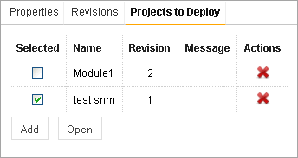
Figure 95: Deploy Configuration with projects to deploy
The Projects to Deploy tab displays existing projects to deploy of the selected deploy configuration.
- To add a new project to deploy, click Add and specify the project and revision to be included in the deploy configuration.
- Repeat this procedure to add as many projects as required.

Deploying a Deploy Configuration
To deploy a deploy configuration, save it and click Deploy.
Specified projects are deployed to Production Repository and a deployment message is displayed.
Figure 96: Deployment message

Opening Deployed Configurations
Deploy configurations provide the means for tracking the deployment history of project revisions. OpenL Tablets WebStudio provides functionality for quickly opening the deployed configuration revisions. This is especially useful when some time has passed since deployment and a review of files during specific deployments is desired.
To open the specific project revisions included in a deploy configuration, proceed as follows:
- In the Deploy Configuration tree, select the deploy configuration.
- In the right pane, select the Projects to Deploy tab.
- In the Selected column, select the check boxes for projects to be opened.
- Click Open.
The selected project revisions are opened in repository editor.

Redeploying Projects
OpenL Tablets WebStudio provides a function that allows a simple update and redeployment of many related deploy configurations when a particular rule project is modified. This function takes into account the revision of the opened rule project and works correctly, even with older project revisions.
To update related deploy configurations and redeploy a rule project, proceed as follows:
- In the Projects tree, select the modified rule project.
- In the right pane, click Deploy.
Note: The Deploy button is disabled if the selected project has the Local status or if it is edited.
The Auto Deploy window appears listing all existing deploy configurations whose latest revision contains a reference to the selected rule project. Deploy configurations marked for deletion are not displayed.
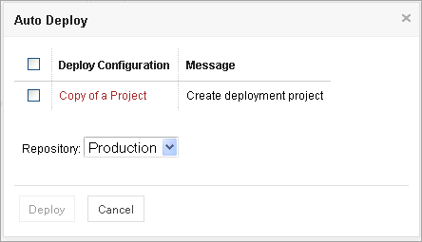
Figure 97: Deploying a project
The Message column displays the current status of displayed deploy configurations. If a particular deploy configuration cannot be deployed, the check box is gray. Following are possible reasons for a deploy configuration to be disabled:
- The deploy configuration is saved.
- The deploy configuration is locked by another user and cannot be updated.
- The deploy configuration is up to date and references the selected revision of the rule project.
- The deploy configuration references a revision of the rule project that is higher than the one currently opened.
If the selected rule project is not referenced by any existing deploy configuration, the system offers to create a new deploy configuration containing only the rule project with an identical name.
- Select check boxes for the deploy configurations that must be updated and deployed.
- Click Deploy.
Update and deployment results are displayed in the user interface.
Figure 98: Redeployment results

Comparing Project Revisions
OpenL Tablets WebStudio provides a function for comparing files and sheets in Excel files between two project revisions.
To compare contents of the currently opened project revision with any other revision, proceed as follows:
- In the project tree, select the project.
- In the right pane, click Compare.
A window appears listing contents of the currently opened project version on the left side and contents of another project version on the right side.
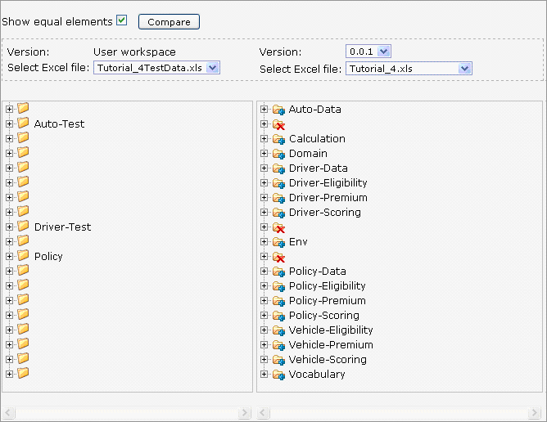
Figure 99: Comparing project versions
Green entries indicate new elements and red crosses indicate deleted or nonexistent elements.
- To compare the current project version with a different version, in the Version list box, select the version number.

Using Administration Tools
This section explains how to view and control OpenL Tablets WebStudio system settings and also describes the user management procedure in the system. To perform administration tasks, click the Administration item in the top line menu. By default, the System Settings tab is displayed.

Managing System Settings
All System Settings are organized into the following groups: Common, Repository and System. To open the desired group, you should click the corresponding icon on the left.
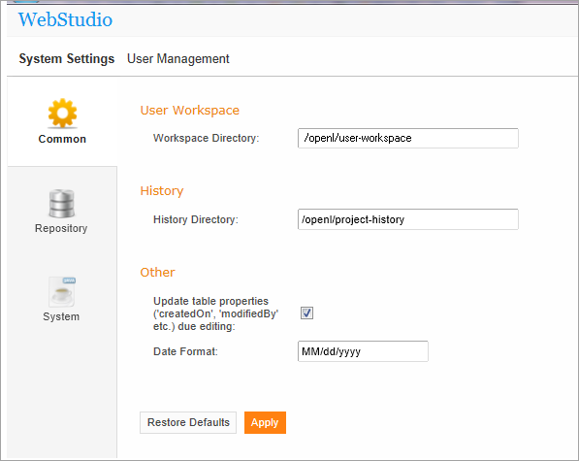
Figure 100: OpenL Tablets WebStudio Administration
Normally, the default settings are recommended but users with appropriate permissions can change them as needed. After making changes, you should click Apply and restart the WebStudio. If you wish to restore the original settings, click the Restore Defaults button.
The following topics are included in this section:
- Common settings
- Repository settings
- System settings

Common Settings
The Common section defines general WebStudio settings described below.
User Workspace
Defines Workspaces Directory where the user’s projects should be located.
History
History Directory – Shows where your projects history files are saved. These files are used to track, compare and revert changes made in projects.
Unlimited numbers of copies – If unchecked makes it possible to define the number of history files to be saved for a project.
To specify a number of history files:
- Clean the Unlimited numbers of copies checkbox (it is selected by default).
- In the The maximum count of saved changes for each project field enter the desired number.
- Click Apply to save your changes.
- Click OK in the confirmation dialog.
You can also clean all the history files for your project. For that:
- Click the Clean history link.
- In the Clean projects history form, select checkbox for a particular project, or select the Name to clear history for all projects.
- Click Clean to complete.
Other
Update table properties… - Indicates whether table properties controlled by the system should be updated and can be viewed in the WebStudio UI. If the option is unchecked, the information about who and when created or modified tables such as Created By/On, Modified By/On would not be added to tables’ properties.
Date Format – Enables changing the date format in the WebStudio Interface.

Repository Settings
Defines which type of repository should be used as a datasource:
- Local – The Repository is located on the local machine as a folder. This folder should be specified in the Repository Directory field.
- Remote - RMI – The Repository is located on a remote server and can be accessed by the RMI protocol. The Repository URL field displays URL for remote access to the repository.
- Remote - WebDav – The Repository is located on a remote server and can be accessed via WebDav protocol. The Repository URL field displays URL for remote access to the repository.
For more information on repository settings refer to the Data Source Configuration section in the OpenL Tablets Web Services Usage and Customizations documentation.
In the Repository tab you can also add more Production repository. For that, click the Add Production Repository link and enter the repository parameters as needed. Do not forget to click Apply to save your changes.

System Settings
The System tab provides the following options:
Custom Spreadsheet Type – indicates whether the Custom Spreadsheet Type Java system feature is turned on or off. By default the feature is turned off. To activate the feature, select the Custom Spreadsheet Type checkbox.
Rules Dispatching Mode – Indicates what rule tables dispatching mode is set:
- Java – is set by default
- Decision Table

User Management
This section describes how to control user access in the OpenL Tablets WebStudio application based on users and user groups. All privileges in the system are assigned at a group level and will be granted to a particular user after he or she is included in a particular group.
You will manage users and groups from the User Management tab which, in turn, is divided into Users and Groups & Privileges tabs. Only members of the Administrators group have rights to manage users and groups in the WebStudio.

Manage Groups
In this section you will learn how to create, modify, and delete a user group with a certain set of privileges. The Administrators group cannot be deleted from the system.
- From the Administration tab, click User Management on the top-left of the screen.
- Click Groups & Privileges at the left. The system displays a list of groups similar to the following one:
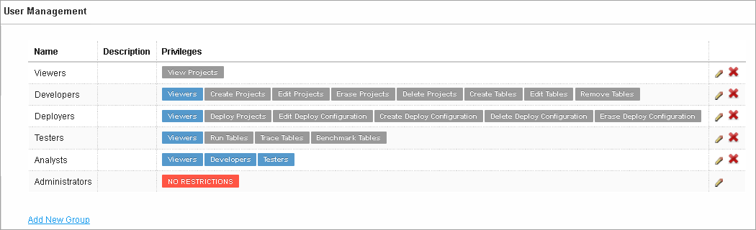
Figure 101: User groups in the Groups & Privileges tab
From here, you can create a new group, and edit or delete an existing one.
To add a new group:
- Click the Add New Group link. The Add New Group form appears.
- Enter the group name in the Name field.
- Enter any useful information in the Description text box (optional).
- In the Privilege area select the privileges as you need. You can also assign a set of privileges for the group by clicking the name of the group above the list of privileges (Developers, Deployers, etc). The Viewers group is selected for a new user group by default.
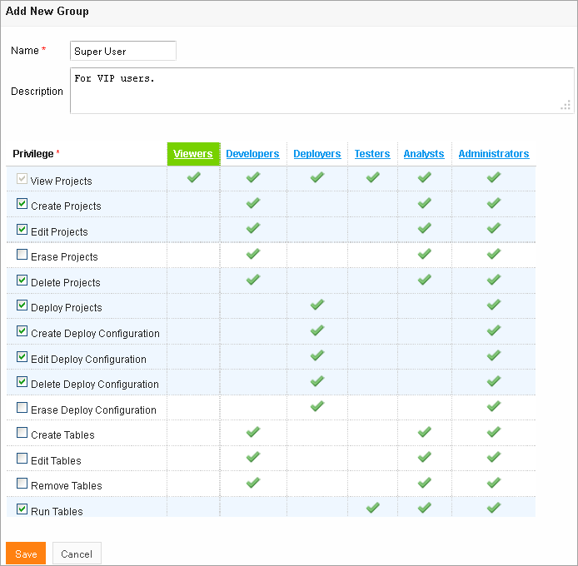
Figure 102: Add a new user group with required set of privileges
- Click Save to save your work.
To modify a User Group:
- Locate the group you wish to change in the list of groups and click the Edit icon .
- In the Edit Group form, you can change the group name, add or modify its description and change privileges as needed.
- Click Save to complete.
To delete a User Group:
- Locate the group to be deleted and click the red cross at the right: .
- Click OK in the confirmation dialog.

Manage Users
Users get access to WebStudio functions by including them in particular group(s).
By default, there are the following users in OpenL Tablets WebStudio.
User name | User password | Groups
user | user | Viewers
u0 | u0 | Testers
u1 | u1 | Developers, Analysts
u2 | u2 | Viewers
u3 | u3 | Viewers
u4 | u4 | Deployers
a1 | a1 | Administrators
On the first start of the WebStudio you are provided with a1/a1 login/password pair that gives you Administrator’s permissions. You can then set up your users in the WebStudio as you need. For information about the permissions of the groups, refer to the Manage Groups section above.

While creating a new user, you should include the user in at least one group.
- From the Administration tab, click User Management at the top-left of the screen.
- Click Users at the left. The system displays a list of WebStudio users.
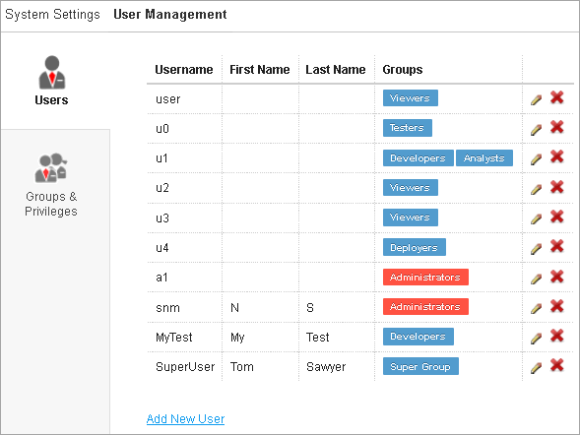
Figure 103: List of OpenL Tablets WebStudio Users
From the Users tab you can create, modify or delete user from the system.
To create a new User:
- Click the Add New User link. The system displays the Add New User form.
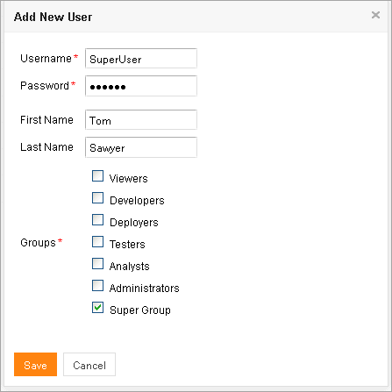
Figure 104: Creating a new user
- Specify the user’s login in the Username field and enter the password in the Password field.
- Enter the user’s first and last name (optional).
- Select one or more groups to assign the user to.
- Click Save to complete.
The system displays the new user in the Users list.
To modify a User:
- Locate the user you wish to modify in the Users list and click the Edit icon: .
- In the Edit User form, you can change the user First Name, Last Name and select or deselect the groups to include the user in.
- Click Save to save your changes.
To delete a user:
Warning: You must have at least one Administrator (a member of the Administrators group) in the WebStudio, i.e. you cannot delete the only WebStudio Administrator.
- Locate the user you want to delete in the Users list and click the Delete icon: .
- Click OK in the confirmation dialog.

Index

A
advanced functionality, 39
B
benchmarking, 54
D
deploy configuration
creating, 73
defining descriptors, 73
deploying, 74
deployed project
opening, 74
Design Repository
browsing, 56
F
file
deleting, 70
uploading, 70
folder
creating, 69
deleting, 70
G
guide
audience, 5
related information, 5
typographic conventions, 5
M
module
opening, 19
O
OpenL Tablets WebStudio
components, 8
definition, 7
logging in, 10
security, 9
user interface, 10
working with projects, 7
OpenL Tablets WebStudio, 7
P
project
closing, 64
compare versions, 19
copying, 71
creating, 57, 61
deleting, 72
deploying, 73
deployment, 73
editing, 19, 64
erasing, 72
managing, 19
modifying, 66
modifying contents, 69
modifying properties, 66
opening, 63
redeploying, 75
removing, 72
revert changes, 19
saving, 19, 64
project dependency
defining, 65
project tree
filtering, 57
project versions
comparing, 76
R
repository editor, 16
using, 56
rules editor, 10
managing projects, 19
opening a module, 19
overview, 11
using, 18
view modes, 12
S
search
advanced, 30
modes, 29
performing, 29
simple, 29
security, 9
T
tables
modifying, 23
viewing, 22
tracing, 50
U
unit tests, 46
V
view modes, 12

